PEIGI CHAI PEI YIN BCS24090055

CSS3344 Lab 03 - Rajang River Cruise
Source code: https://github.com/peigiii/rajang-river-cruise-lab03
MVVM project structure
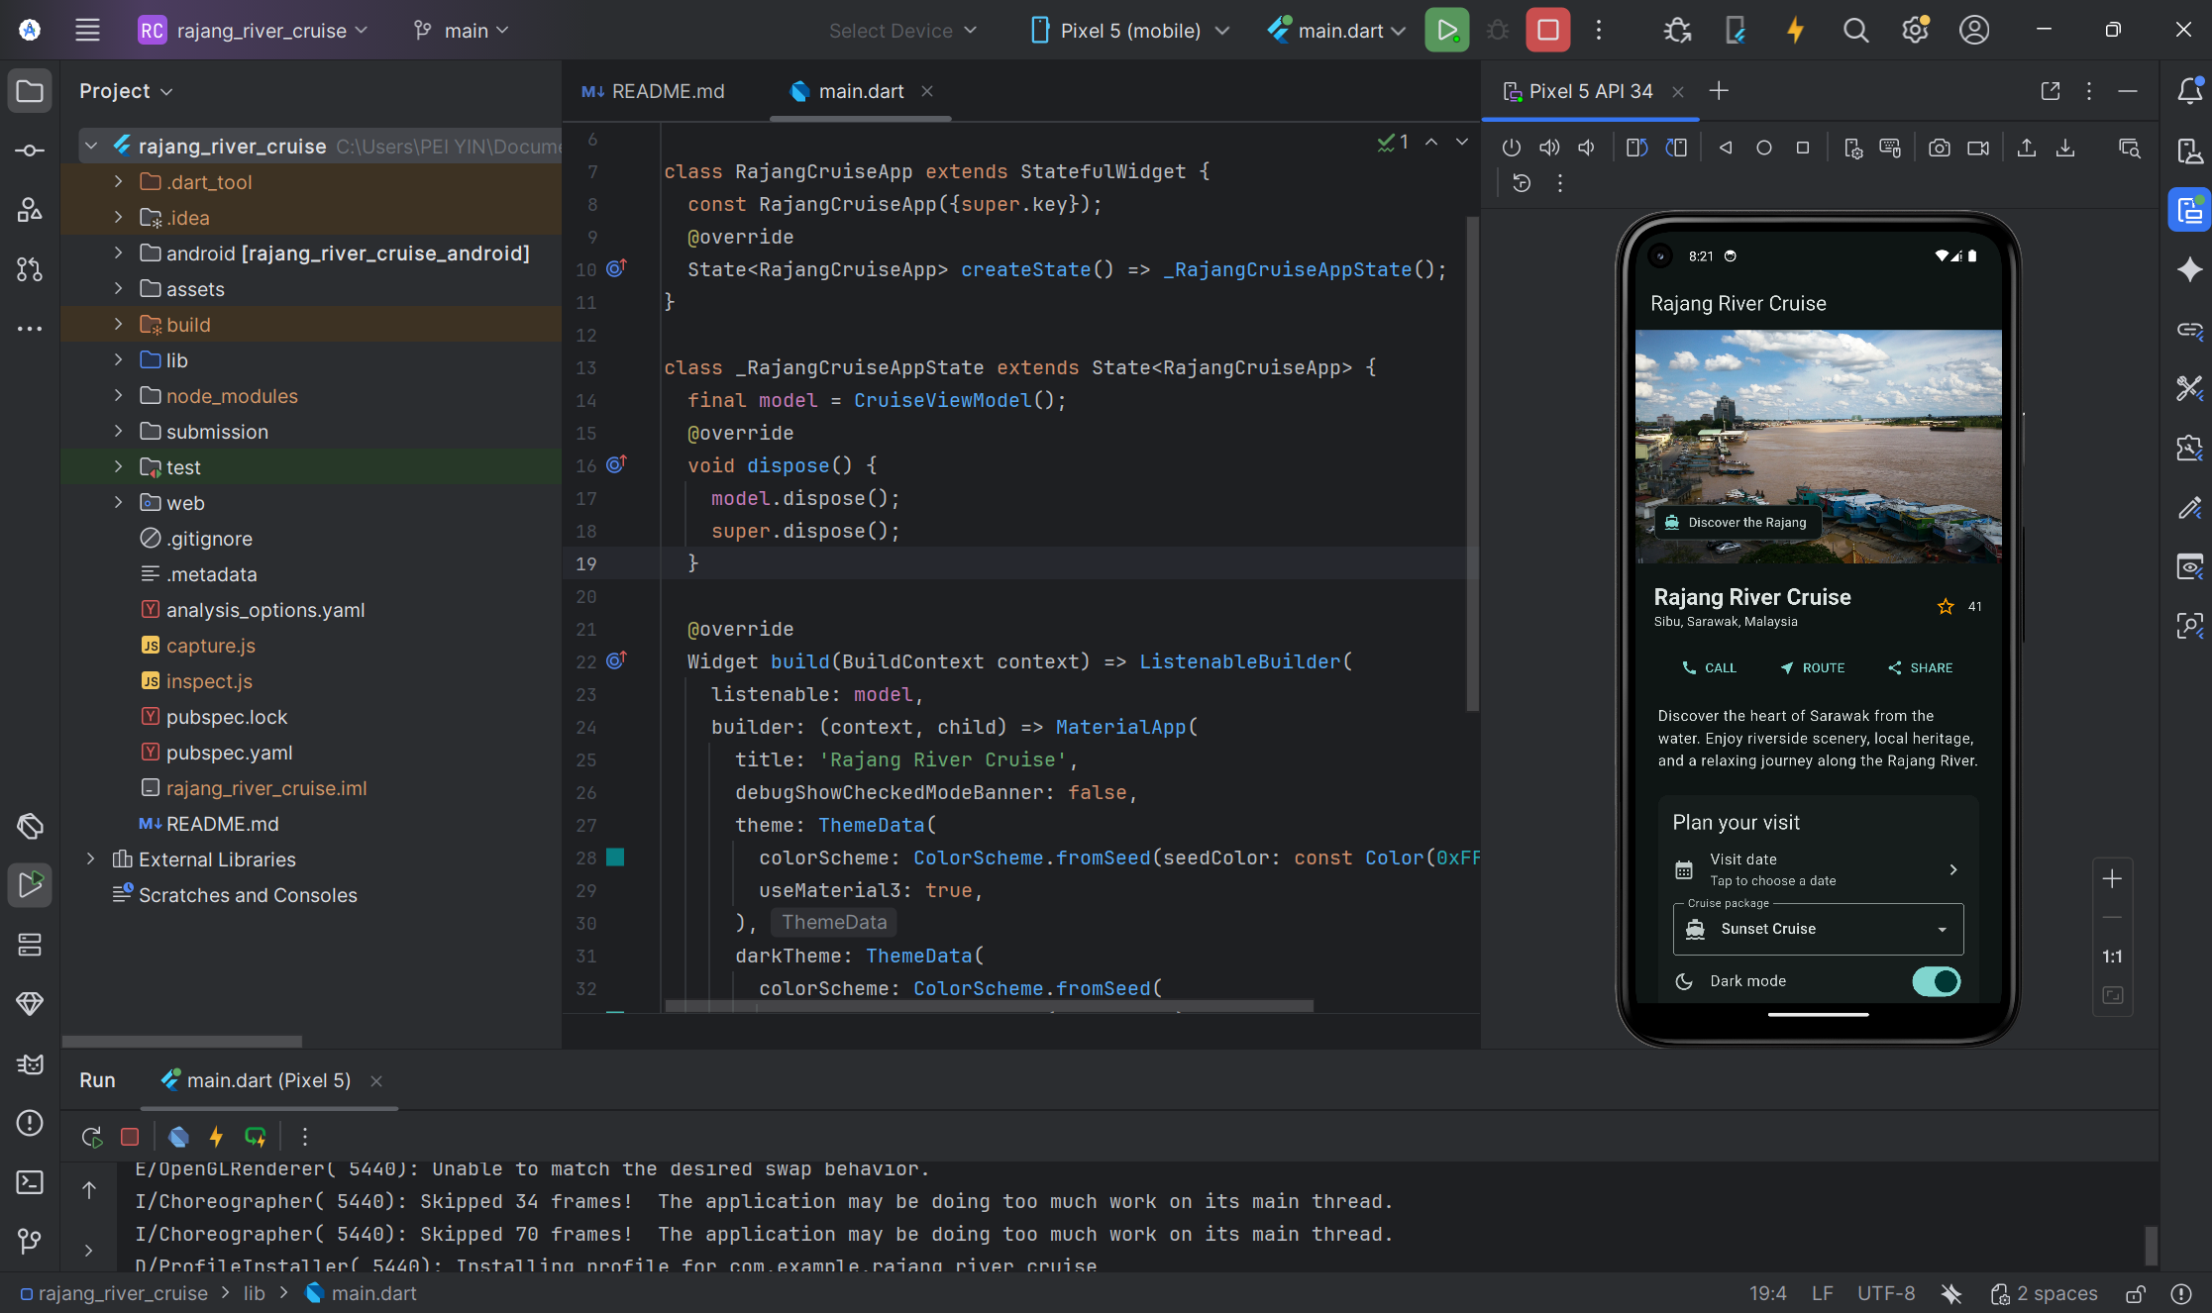

Reflection
The main challenge was keeping the same booking controls usable in portrait and landscape without duplicating state. I placed the shared detail content in a scrolling column for portrait and beside the image in a Row with Expanded panes for landscape. The CruiseViewModel owns the date, package, theme and star state; the modular widgets listen to it so changes appear immediately. I also resolved a damaged Gradle cache, rebuilt the Android app in Android Studio, and verified it on the Pixel 5 emulator.

Portrait and dynamic star count
Both images were captured from the Pixel 5 emulator after the Android app ran in Android Studio.
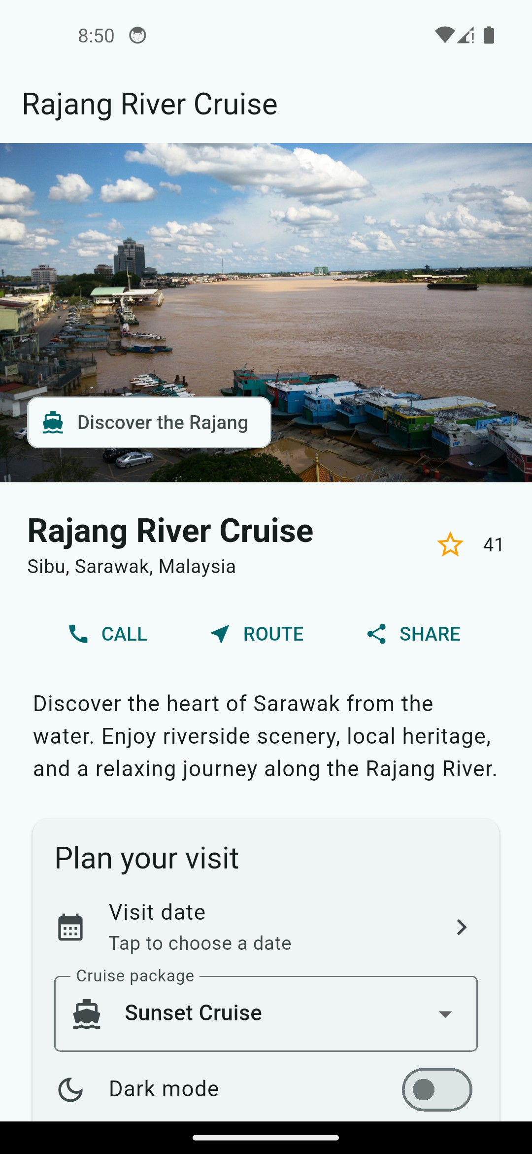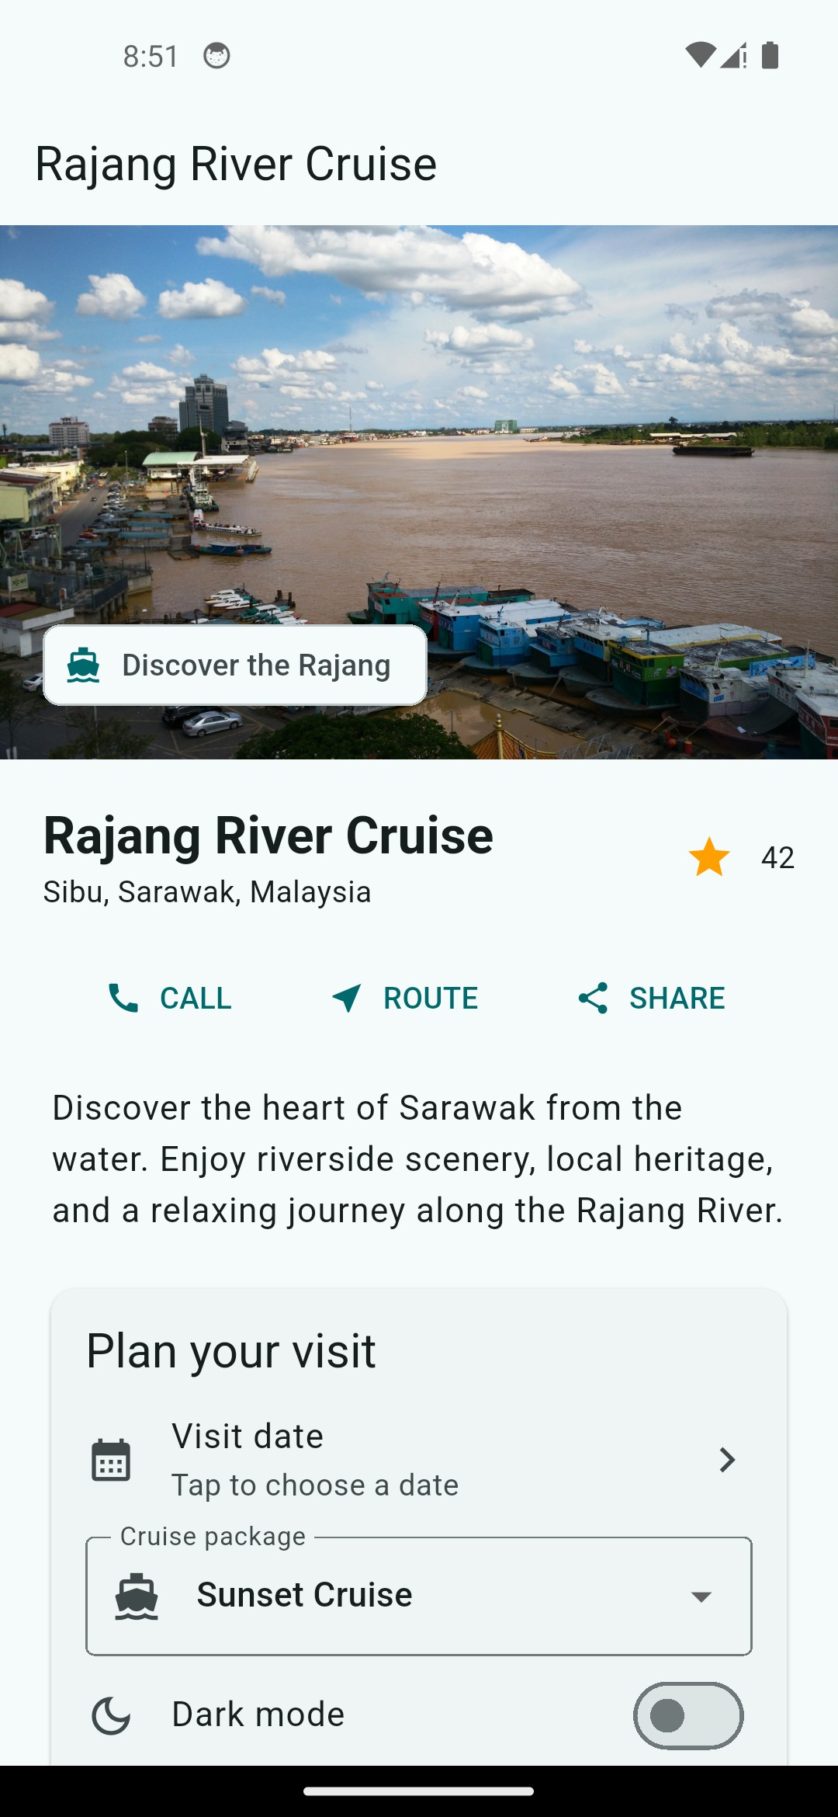
Light theme - 41 stars (before) Star selected - 42 stars (after)

Responsive landscape layout
The image and details appear side by side in landscape orientation.
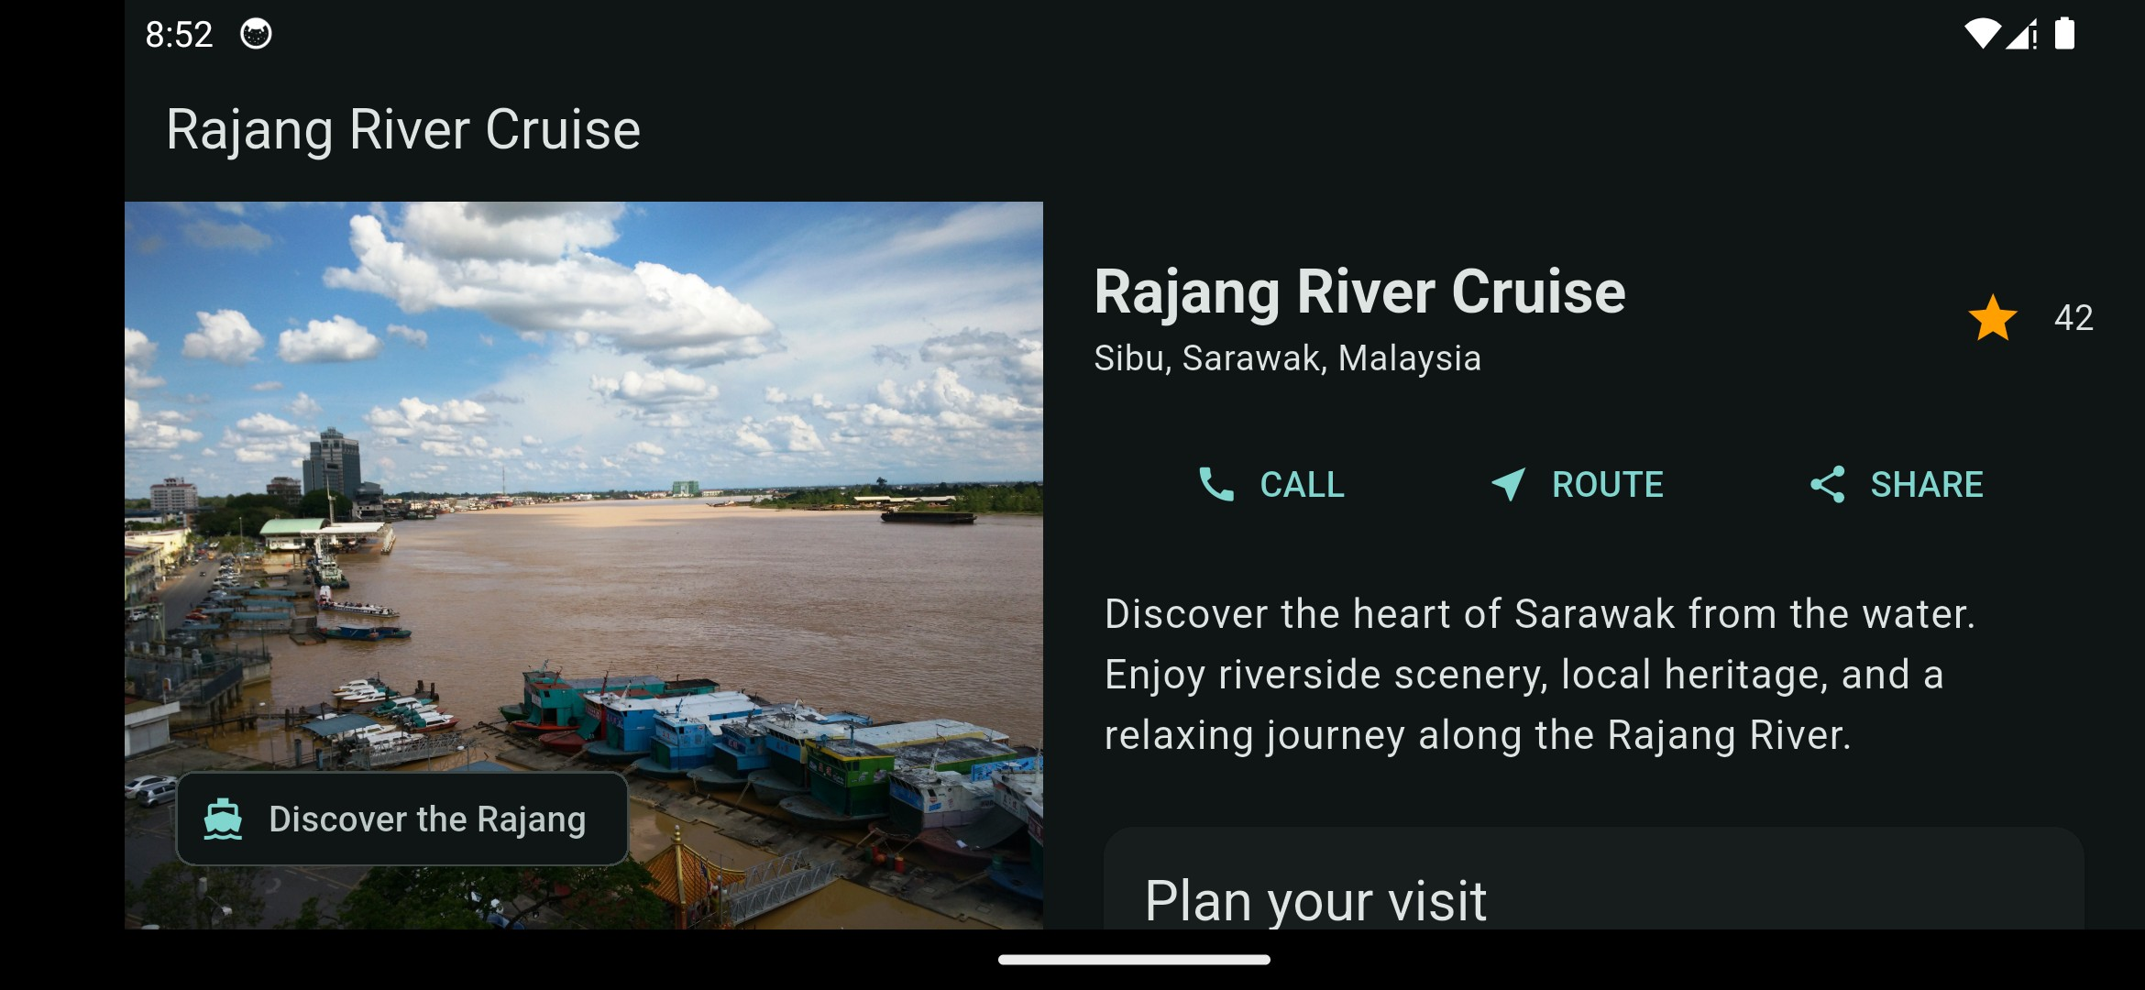
Pixel 5 emulator - landscape split pane, dark theme active

Interactive controls and theme
The date picker opens from the visit date tile. The switch updates the complete app theme.
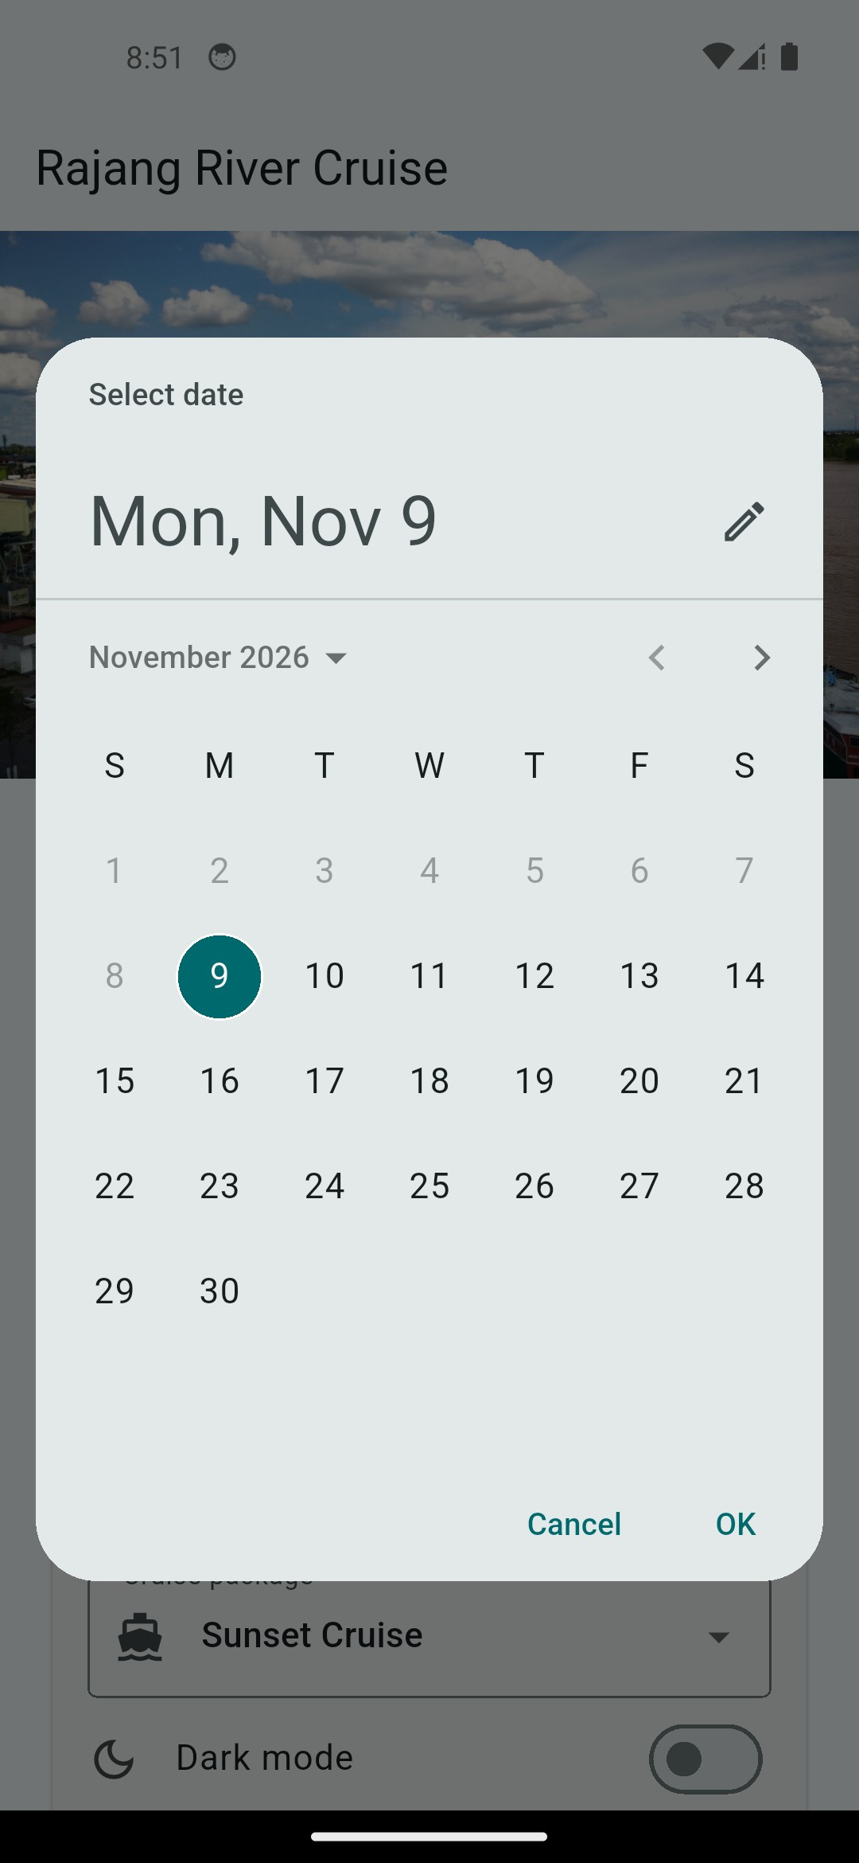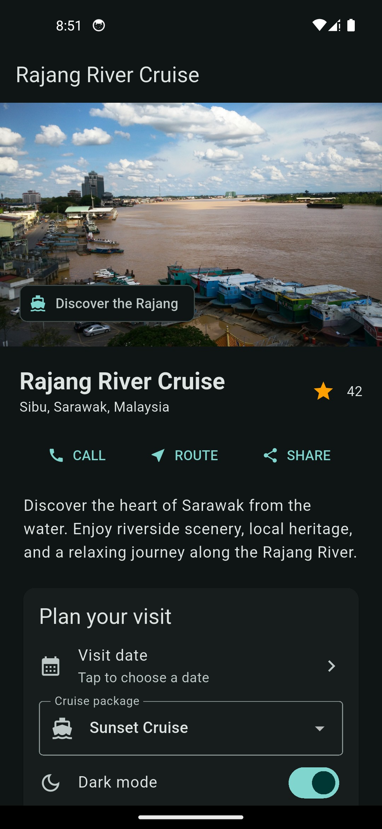
Visit date picker open Dark mode enabled

